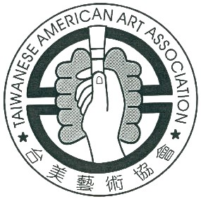 | Taiwanese American Art Association  1638 kiowa Crest Dr. Tel: 562-310-6758  Diamond Bar, CA 91765 Tel: 626-289-8202  echoidea@yahoo.com Tel: 909-396-7553  Tel: 626-375-8909

Artwork Entry Form (台美藝 術展)

English Name | First Last
中 文 名
Age
Address | No/street City State Zip
Telephone | e-mail:
Title of Artworks | 1. 2.  English: 3. 4.  5. 6.  1. 2.  中文: 3. 4.  5. 6.
Entry Number | (Official use; do not write)  Adult: Children:

Title of Artworks | (Please duplicate & print this part as above)  1. 2.  English: 3. 4.  5. 6.  1. 2.  中文: 3. 4.  5. 6.
Entry Number | (Official use; do not write)  Adult: Children:

